DS 522 Data Acquisition and Analytics
HOS02A-1 – Python Built-in Data Structures and Sequences
06/15/2024 Developed by Catherine Ata
04/08/2025 Reviewed by Naveena Moddu
2/13/2026 Revised by Jonathan Koerber
03/26/2026 Reviewed by Vishal Krishna Kumar

School of Technology & Computing (STC) @ City University of Seattle (CityU)
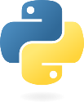

Take Note Before Starting
• The directory path shown in screenshots may be different from your directory.
• Not every step is explained in the tutorial. If you are not sure what to do:
1. Consult the resources listed below.
2. If you cannot solve the problem after a few tries, email your course TA for help.

Learning Outcomes
• Understand Python’s different data structures
• Understand the functions and methods for these data structures
• Learn how to use the different functions and methods
• Learn how to access and modify the elements in the data structures

Resources
- McKinney. (2022). Python for Data Analysis (3rd edition).
- Python.org. (2024). Python documentation. https://docs.python.org/3/
- Tutorials Point. (2024). Python Tutorial. https://www.tutorialspoint.com/python/index.htm
- W3 Schools. (2024). Python Variables. https://www.w3schools.com/python/python_lists.asp

Incorporating AI into your Learning Workflow
In this course, we embrace the future of development. Tools like GitHub Copilot, Gemini, and ChatGPT are integrated into modern environments like GitHub Codespaces and VS Code. Our goal is to use these tools not as "answer engines," but as Socratic Tutors.
The "Socratic Tutor" Philosophy
A Socratic tutor doesn't give you the answer; they ask the right questions to help you find the answer yourself. When using AI, your goal is to understand the logic, not just the output.
Guide for best results:
- Explain, Don't Replace: Use AI to explain error messages or logic. Never copy-paste code without being able to explain what every line does.
- The 10-Minute Rule: If you are stuck on a "creative judgment" problem for more than 10 minutes, describe your problem to the AI and ask for a "hint" rather than the full solution.
- Verify the Output: AI can sometimes "hallucinate" (make mistakes). Always compare the AI’s explanation with the actual results you see.
- Cite Your Assistant: If an AI helps you solve a particularly difficult bug, add a comment in your code like: # Logic assisted by AI to resolve non-numeric error
Answer Challenges by referring to your choice of AI Chat. Include your prompt pay special attention to how the prompt effects the response outcome.

Getting Started
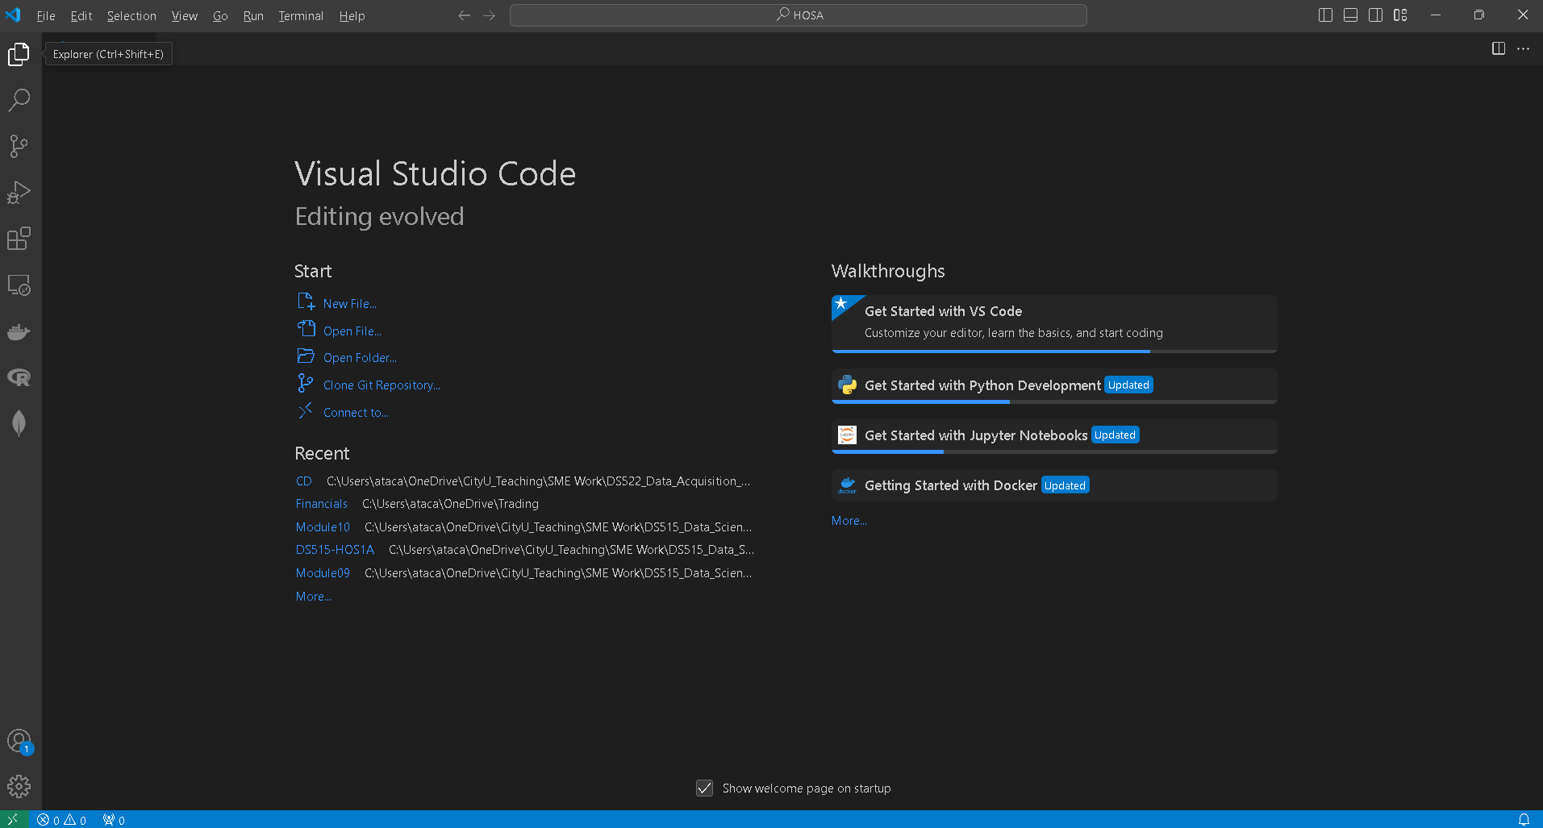
- Open the VS code and within - VS Code, open the DS522 course folder created earlier. On the menu tab, select File, then Open New Folder. Navigate to your work directory or GitHub repository that you have cloned. For example: C:\Users\my_workspace\Desktop\DS522
OR C:\Users\my_workspace\Desktop\DS522\github_repository_name

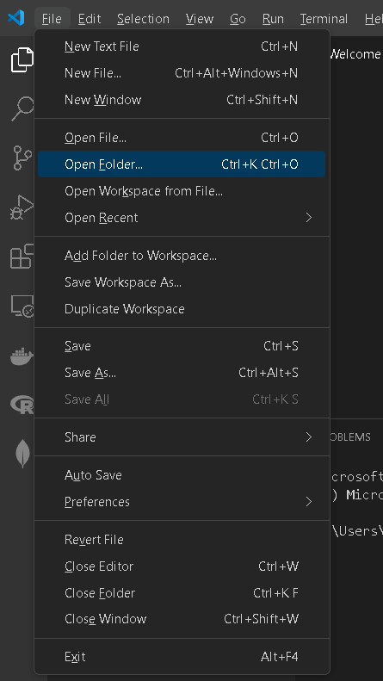
NOTE: If you have cloned a GitHub repository that is provided specifically for this course, navigate to that directory and skip steps 2 to 4. This will be the folder where you will be storing all your HOS02A work.

- Once in your work directory, go to the menu tab again, select Terminal, select New Terminal to open a Command Line Interface (CLI) like the Command Prompt or PowerShell for Windows OS.
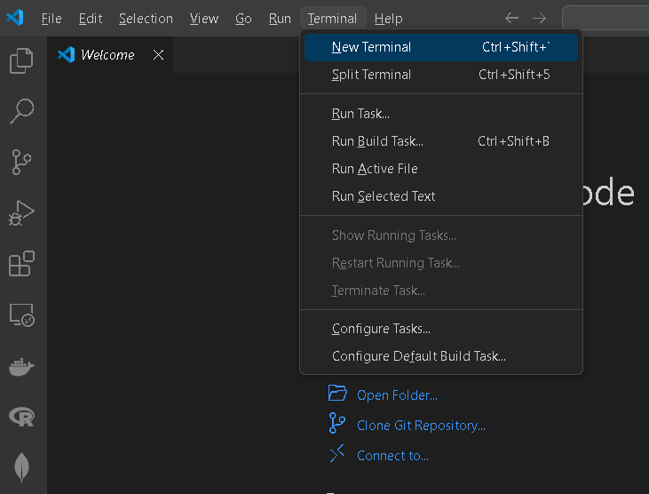

- Inside your “DS522” directory, create a new directory and name it “Module02”. Use the following command:
>mkdir Module02
- Move to the new directory. Use the following command:
>cd Module02

NOTE: This will be the folder where you will be storing all your HOS02A work.

Python Data Structures and Sequences

What is Data Structure?
Organizing, managing and storing data is important as it enables easier access and efficient modifications. Data Structures allow you to organize your data in such a way that it enables you to store collections of data, relate, and perform operations and manipulations on your data.

Types of Built-in Data Structures in Python
Python has implicit support for Data Structures which enable you to store and access data. These structures are called List, Dictionary, Tuple, and Set. These make programming easier and help programmers use them to obtain solutions faster.

Lists
Lists are used to store data of different data types in a sequential manner. There are addresses assigned to every element of the list, which is called an Index. The index value starts from 0 and goes on until the last element is called the positive index, while negative index starts from -1 which allows you to access elements from last to first.
The list is the most versatile datatype available in Python which can be written as a list of comma-separated values (items) between square brackets. An important thing about a list is that items in a list need not be of the same type.

Creating Lists
Creating a list is as simple as putting different comma-separated values between square brackets.

1. Under the Module02 folder create a file named list_.py and type the following code:
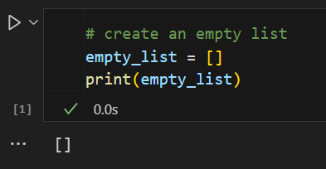
Run the code and the output will be an empty pair of square brackets as shown below the cell from the above figure:

2. Let us create another list with string and integer data types to understand how lists work. Add the following code to the list_.py script:

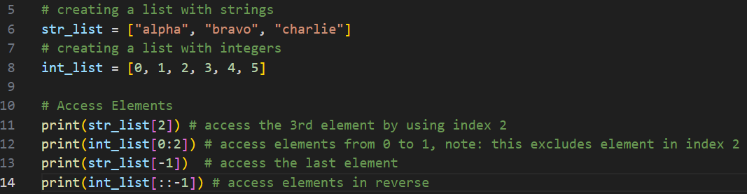

Accessing Elements
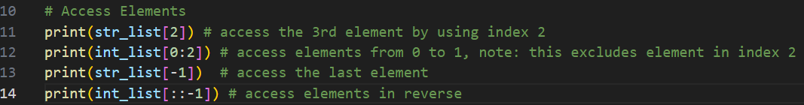
3. To access elements in lists, we use the square brackets for slicing and pass the index values. Type the following code to the same script.

After running the code, you should see this output:
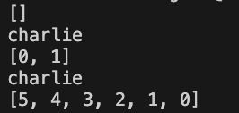

Updating Element Values in a List
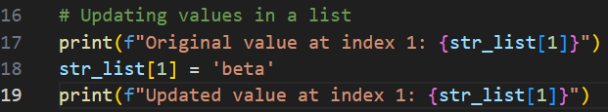
4. To update the element values in lists, again we use the square brackets and pass the index value. Type the following code to the same script.

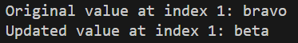
Run the code and each print call should have different output as seen below:

Adding Elements
There are methods that we can use to add elements in a list, we can use append, insert, and extend.
- The append () function adds all the elements passed to it as a single element.
- The insert () function adds the element passed to the index value and increases the size of the list too.
- The extend() function adds the elements one-by-one into the list.
The simplest way to add a new element to a list is to append the item to the list. When you append an item to a list, the new element is added to the end of the list. The append () method makes it easy to build lists dynamically.
- Let us use append method to add elements to the lists. Type the following code to the same script:
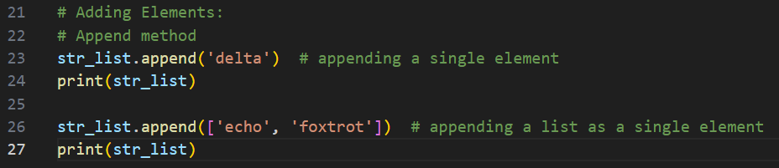
Run the code and check the output:

As you can see, the list of strings passed to the append method is added as a single element to the str_list, making it a nested list.

To add a new element to your list at any position, we use the insert () method, and we pass it with the index of the new element and the value of the new element.

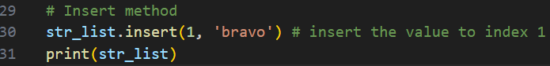
- Let us use an insert to add a new element to the list. Type the following code to the same script:
Run the code and check the output:

The extend method is used to extend the list by appending all the elements in another iterable such as another list, tuple, set, or a string, wherein their elements will be added to the end of the list one at a time.

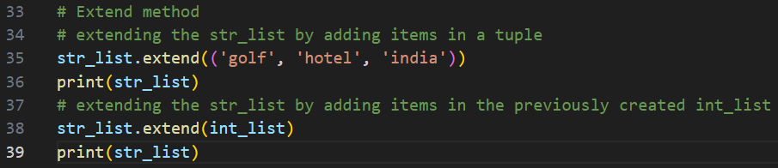
- Let us use extend to add more elements to the str_list. Type the following code to the same script:

Again, run the code and check the output:

Joining Lists
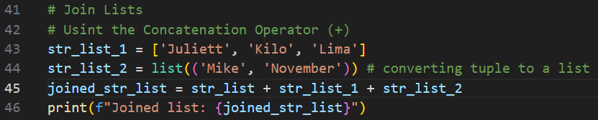
In Python, we can combine the elements of multiple lists into a single list. Python provides numerous ways to join lists, in addition to using built-in methods like append() and extend() that you have seen earlier, you can join lists using concatenation and list comprehension.

- In the same list_.py Python script, type the following codes:
Run and check output:

- Let us use list comprehension to combine two lists. Add the following lines of code to your existing list_.py script:

Again, run the code and check the output in terminal:

Challenge: What is the difference between concatingating a list with a “+ “ operator and using the extend method. When would you choose to use one method over another.

Removing Elements in a List
We can remove an element from a list using various methods:
- pop () method - removes the last item in a list, but it lets you work with that item after removing it. The term pop comes from thinking of a list as a stack of items and popping one item off the top of the stack. In this analogy, the top of a stack corresponds to the end of a list. You can use pop () to remove an item from any position in a list by including the index of the item you want to remove in parentheses; without the argument (index number), it removes and returns the last item.
- remove () method - used if you only know the value of the item you want to remove and removes the first occurrence of the item.
- clear () method - removes all elements in the list, leaving an empty list.
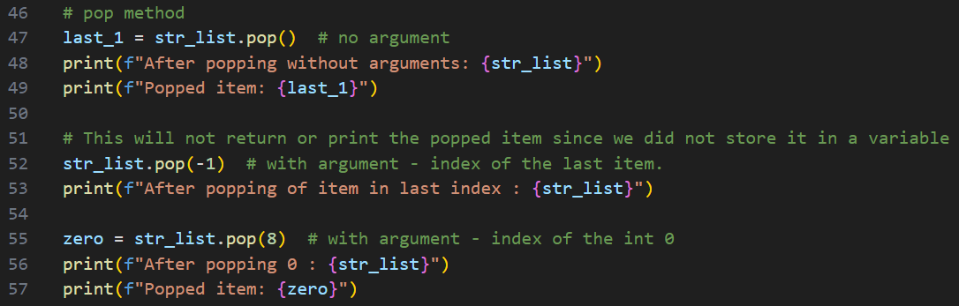
- del statement - used when you know the specific index of the item you want to remove from a list or for deleting the complete list.

Let us remove an item using the remove () method.

- In the same list_.py Python script, type the following codes:

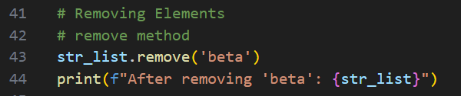
Run the code and check the output:
Let us remove and return an item using the pop () method.

- Type the following code to the list_.py script:

Run the code and check the output:

Let us remove all the items in a list using the clear () method.

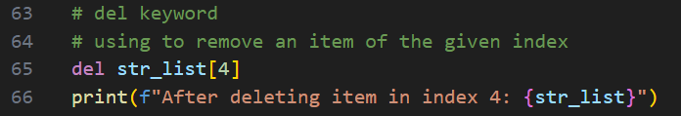
- Type the following code to clear the items in the int_list that we previously created: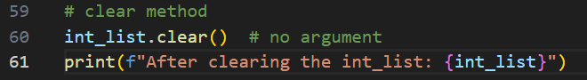

Run the code and check the output:
Let us remove an item from a list using the del keyword and then delete the complete list.

- Type the following code to remove an item in index 4 of the str_list:

Run the code and check the output:

- Type the following code to delete the entire int_list:

Run the code and check the output:

Looping through the items in a List
In a for loop, you can access each item in a sequence using a variable, allowing you to perform operations or logic based on that item value. We can loop through list items using for loop by iterating over each item in the list.

- Type the following code to iterate over the str_list: 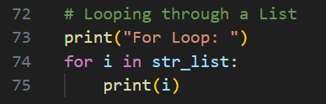
Run the code and check output (NOTE: comment out the print statement after the del int_list line before :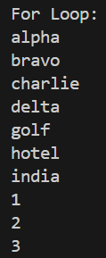

List Comprehension
List comprehension in Python is a concise way to create lists by applying an expression to each element of an iterable.

- Type the following code to iterate over the str_list using a list comprehension: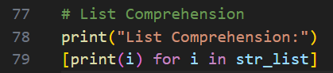

Run the code and check output:
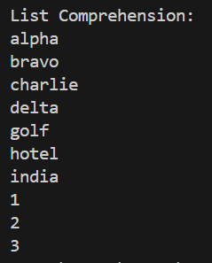

Sorting/ Ordering Lists
We can arrange the items in a list in either ascending or descending order. In Python, we can do that by using a built-in function sorted() or using the sort() method.

Using sort () method

The python sort () method is used to sort the elements of a list in place; meaning it modifies the original list without returning a new list.
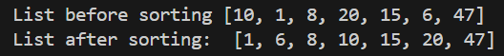
- Type the following code to the list_.py script: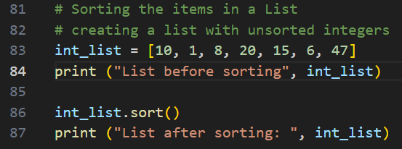
Run the code and check output:
Using sorted() Function
In contrast, Python’s sorted() function is a built-in function used to sort the elements of an iterable and returns a new sorted list, leaving the original iterable unchanged.
- Type the following code to the list_.py script:
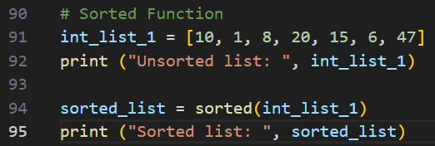
Run the code and check the output: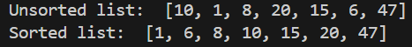
Using Reverse method
The reverse method, as the name suggests, reverses the order of the items/elements in a list in place, meaning it will not return to a new list, but it will change the list.
- Again, type the following code to the same Python script:
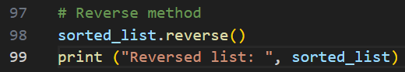
Run the code, the output should be like this:

Tuples
A tuple is a sequence of immutable Python objects. The tuple data type is like a list, except
tuples are typed with parentheses and cannot be modified, appended, or removed. The elements in a tuple can also be of different data types. Below are examples of tuples:
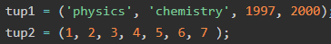

Creating Tuples
Similarly, creating a tuple is as simple as putting different comma-separated values between parentheses.
  - Under the Module02 folder create a file named tuples_.py and type the following code:
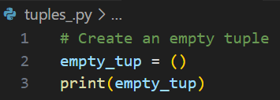
Again, run the code and check your output in the terminal.

In this first example, we are simply creating a tuple with no elements. Because tuples are immutable, we cannot add elements in it. However, you can use the same variable name and then assign values to it.

  - Add the following to your tuples_.py script:
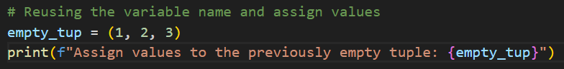

Rerun the script and see the output in the terminal:

  - Let us create more tuples containing elements with different data types. Update your tuples_.py script with the following codes:
  - 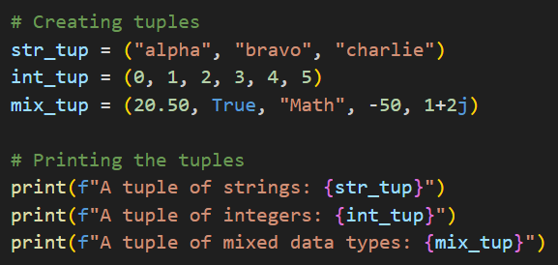
Run the script and see the output in the terminal:
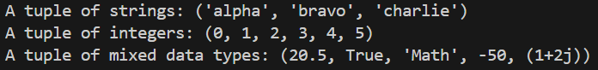

Accessing Tuple Elements
Again, just like lists, each element in a tuple corresponds to an index, and the index starts from 0 (first element) and increments one for each subsequent element. The index of the last item in the tuple is always "length-1", where "length" represents the total number of items in the tuple. To access the elements of a tuple we just need to specify the index of the item we need to access inside a pair of square brackets, for example: tup[0] for the first item.

- Update your tuples_.py script with the following codes:
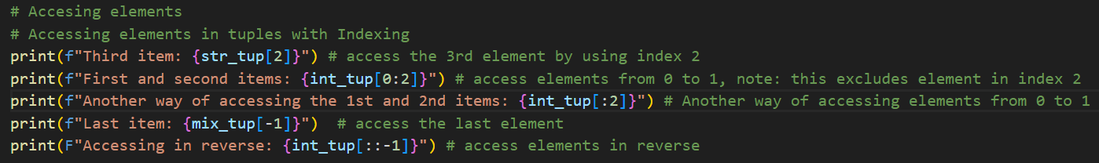
Run and check the output:
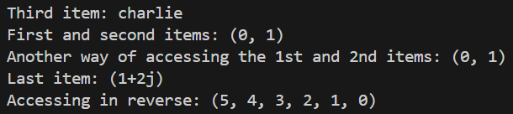

Updating Tuples
Since tuples are immutable sequence, meaning once a tuple is created, its elements cannot be changed, added, or removed.
- Type the following code:
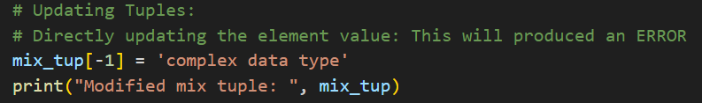
Run and see what happens:

To successfully update a tuple in Python, you can combine various operations to create a new tuple. Common ways to do that are by using concatenation and list comprehension. The latter involves using a list and then converting it to a tuple.

- Let us create an updated tuple using concatenation and assigning it to a different variable; type the following code to the tuples_.py script:
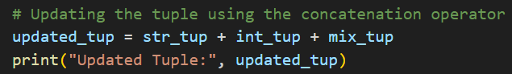
Run the code and see the output: (NOTE: Comment out the previous code)

- This time, let us use list comprehension. Update the script with these additional codes:
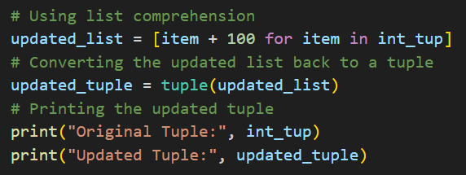
Rerun the script and check the output:
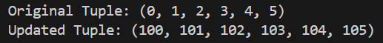

- Using the append method with additional operations is another way to update a tuple. Add these codes to the tuples_.py script:
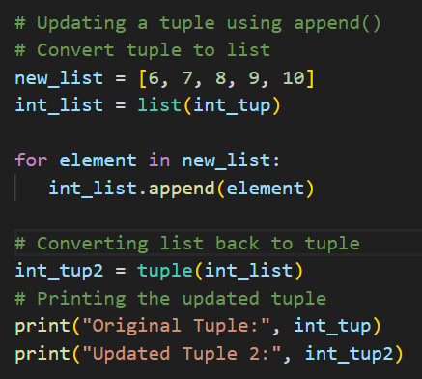
Rerun the script and check the output:
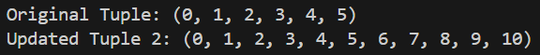

Unpacking Tuples
This process parse tuple items in individual variables.

- Type the following code to your existing script:
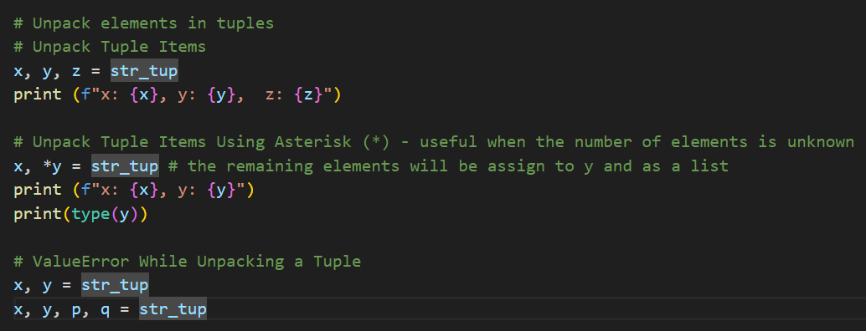

Run the script again and check the output.
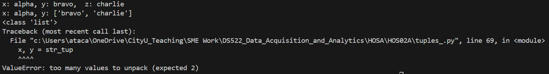

The last example will produce an error message; the variables should be the same length as the number of elements in the tuple. However, using the asterisk (*) in front of one of the variables as in the second example prevents this error. This is useful when the number of elements is unknown, or when you want to assign parts of a tuple to a different variable for other operations.

Loop Through Tuple Items
Python allows us to iterate over each element in tuples sequentially as well. We can achieve this in several ways, with the most common being the for loop. We can also use the while loop to iterate through tuple items, although it requires additional handling of the loop control variable explicitly, i.e., an index.

- Let us use a for loop to iterate through the elements in a tuple; update your script and add the codes below:
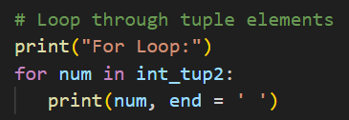

Run the code and check the output: (Make sure you comment out the code that caused ValueError from number 9).
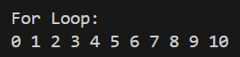

- Now, let us use a while loop to iterate through the elements in a tuple; update your script and add the codes below:
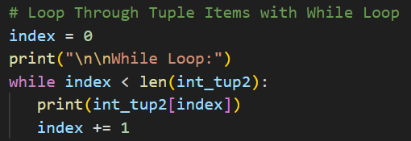
Run the code and check the output:
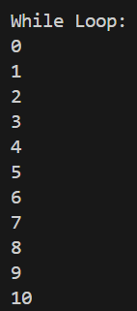

- Lastly, let us use indexing to loop through the tuple elements. Type the code below to the existing script:
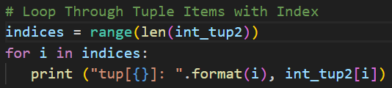
Execute the code and check the output:
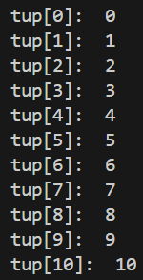

Sorting Tuples
- The code below sort tuples based on the first elements of the tuples:
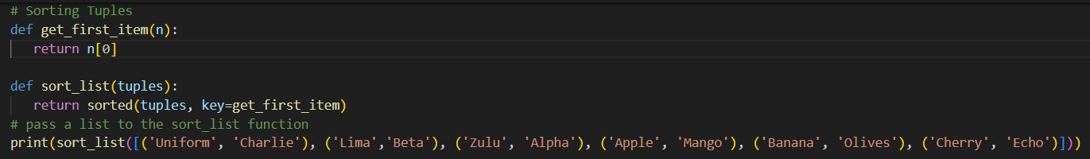
Run and check the output:

Challenge: How does Python store a tuple in memory how is that different from lists and Dictionary.
Dictionary
A dictionary is a built-in Python data type that stores a mutakljble and unordered collection of data in a key: value pair form. A collection of such pairs is enclosed in curly brackets; each pair is separated by a comma; and each key is separated from its value by a colon (:). Each key is unique and maps to a value. Keys and Values can be of any data type; thus, dictionaries are heterogeneous, however, dictionaries do not accept mutable objects like a list as a key, this will raise a TypeError.
Example:
dict1 = {"name": "John", "age": 36}
You can perform several operations to dictionaries like accessing values, updating the dictionary, adding new pairs, and deleting the elements.

  - In your Module02 folder, create a file named dictionary.py, then type the following code:
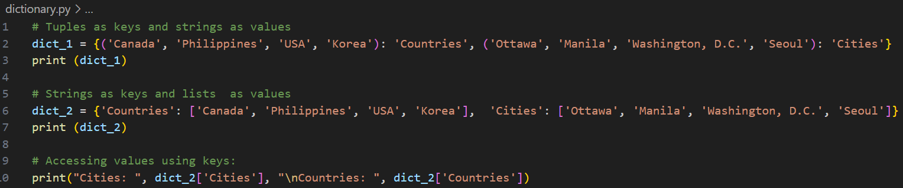
Check the output by running the code:

Just like the other mutable sequence type data, you can update a dictionary, and its values, except when the value is immutable like a tuple. You can also delete items in a dictionary.
  - Add the codes below to your dictionary.py script:
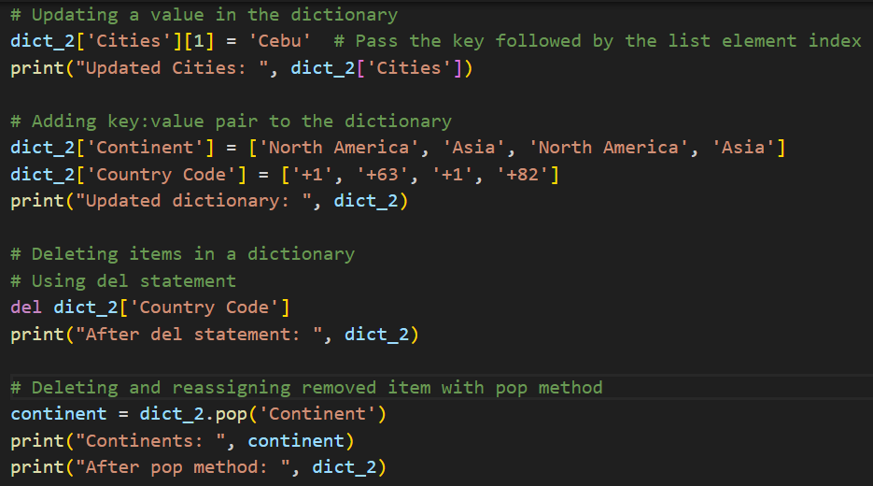
Run and check the output:

If the key you passed does not exist, you will get an error. More than one entry per key is not
allowed. This means no duplicate keys are allowed. When duplicate keys are encountered during assignment, the last assignment wins.

A Dictionary is unordered. Thus, if you compare two dictionaries with the same content but not
the same order, it will return true.

  - Type the following code to compare dictionaries:
Run and check result:

Looping in Dictionaries
A single Python dictionary can contain just a few key-value pairs or millions of pairs. Python lets you loop through a dictionary. You can loop through a dictionary's key-value pairs, through its keys, or through its values.

  - In your dictionary.py, add the following code. This code shows how multiple dictionaries are combined and used a nested for loop for accessing the keys and values.
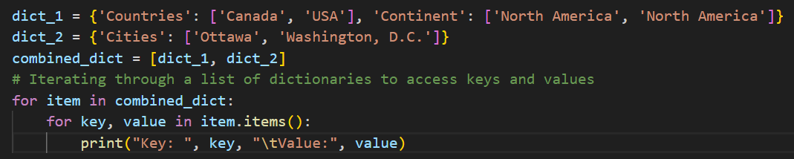
Run and check result:
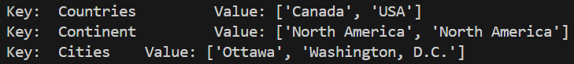

Using the get() Method
The get () method is used to fetch the value associated with the specified key. If the key does not exist, it returns a default value (which is None if not specified).

  - Type the following code to get the highest value in the dictionary:
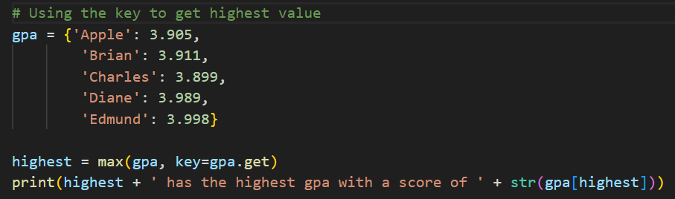
Run and review the output:

In the above example, passing the key as a parameter to the max function and then using gpa.get as the argument is equivalent to gpa.get(key).

Set
A set is an unordered collection of unique elements. Thus, items in a set do not appear in a stipulated manner, i.e., they can appear in a different order every time it is used. Unlike lists or tuples, sets do not allow duplicate values so each element in a set must be unique. Sets are mutable, meaning you can add or remove items after a set has been created. Like dictionaries, they are defined using curly braces {}, but they do not have a mapping format. We can also use the built-in set() function. Sets can contain elements of different data types.
Sets are particularly useful for membership testing, removing duplicates from a sequence, and performing common mathematical set operations like union, intersection, and difference.

Let us try some exercises to understand how sets work.

1. Create a file named Set.py and type the following code:
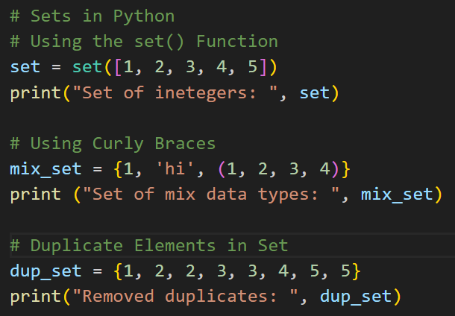
Run the Set.py script and check the output:
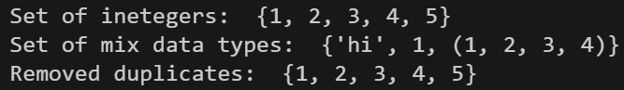
2. Now let us add items to an existing set. Type the codes below to your Set.py script, then run the script to see the output.
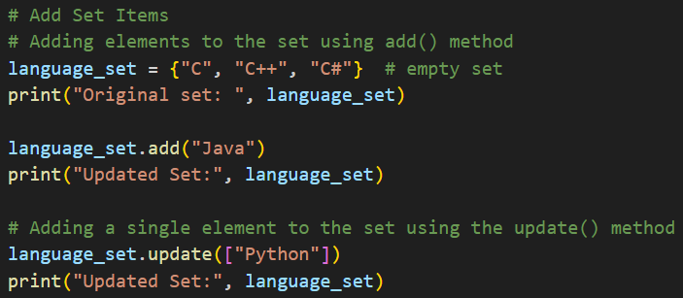

Output:
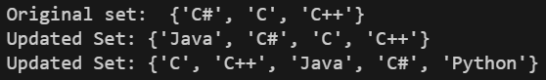

3. This time, let us combine multiple sets together, update your script using the codes below. Run and check the output.
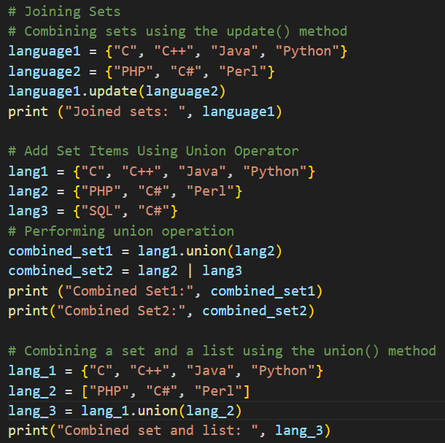

Output:
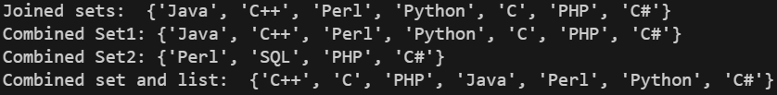

4. Next, we can check if items exist in a set. Update your script by adding the code below; run your script again and see the result.
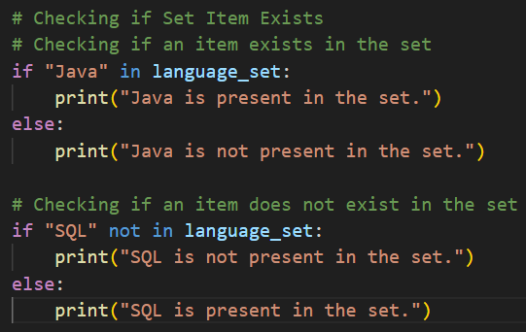
Output:
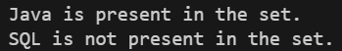

- We can also check if items are subsets; type the following code then run to see the output.
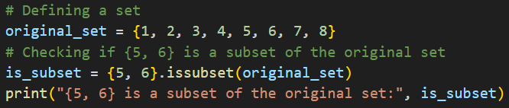

Output:

- To remove items in a set, we can use the remove or discard methods. Add the codes below to your Set.py script. Run and check your output in the terminal.
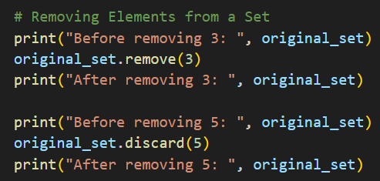

Output:
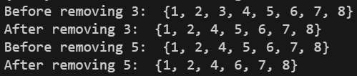

- Lastly, let us create a set using set comprehension and nested set comprehension. Add the following to your script and then run the code:
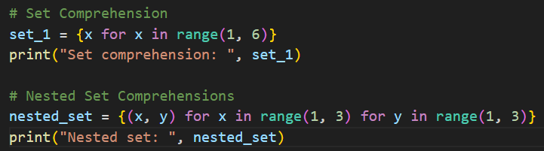
Output:
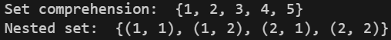

This is the end of the Python Data Structures Exercise. Please proceed to the next HOS2A exercise Python Functions and Files before or after pushing your work to GitHub.

Push your work to GitHub
Follow the instructions on the CityU STC TA Center Github.io Submit your work page

You may also follow the instructions below:
1. Open the cmd terminal for Windows users,
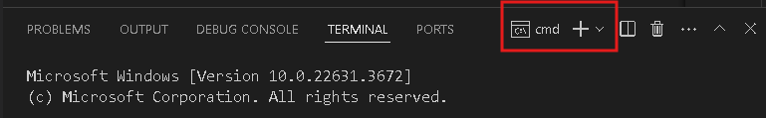

2. After selecting the + button, make sure the terminal is cmd if you have not closed the Python terminal.

If the terminal is not cmd, then you need to add it by opening the drop-down box, choose the Select Default Profile.
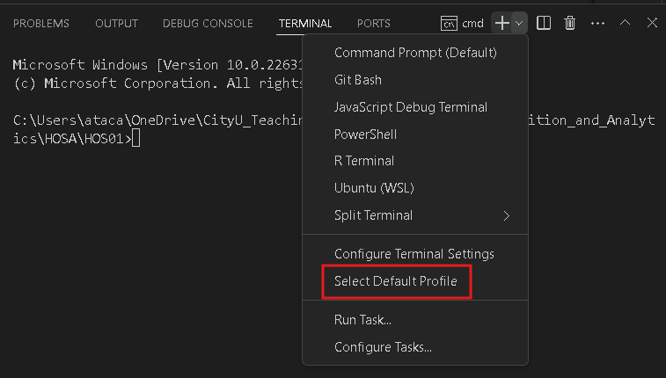

Look for and then select Command Prompt
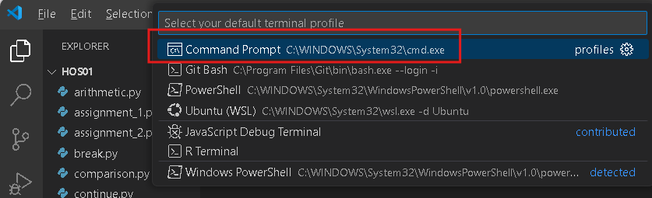

Click the + button. The command prompt will open.

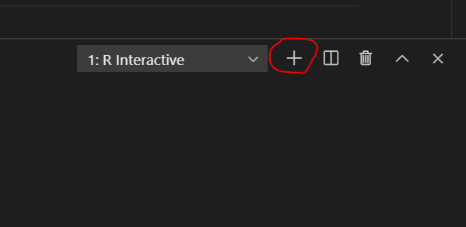

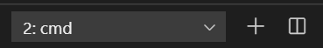

3. Make sure you are in the correct directory/repository: Desktop/DS522/hos02a-courseName-yourUserName

Run the following commands to push your work to the GitHub repository:
Open the terminal from the VSCode by hitting the control + ~ key and type the following command:
>>> git add .
>>> git commit -m “Submission for HOS02A-Data Structures”
>>> git push

*** Please answer HOS02B in Brightspace. ***

